**Computer Networks laboratory**

**Week – 1**

**Task 1**

Step 1: getting the IP/MAC address information and listing the various interfaces

|  |  |  |
| --- | --- | --- |
| Interface name | IP address | MAC address |
| Lo (loopback, up, lower up) | IPv4 - 127.0.0.1/8  IPv6 - 0:0:1/128 | 00:00:00: 00:00:00 |
| Eth0 (broadcast, up, lower up) | IPv4 - 10.0.2.15/24  IPv6 - fe80: a00:27ff: fe1b: b4a5/64 | 08:00:27:1b: b4: a5 |

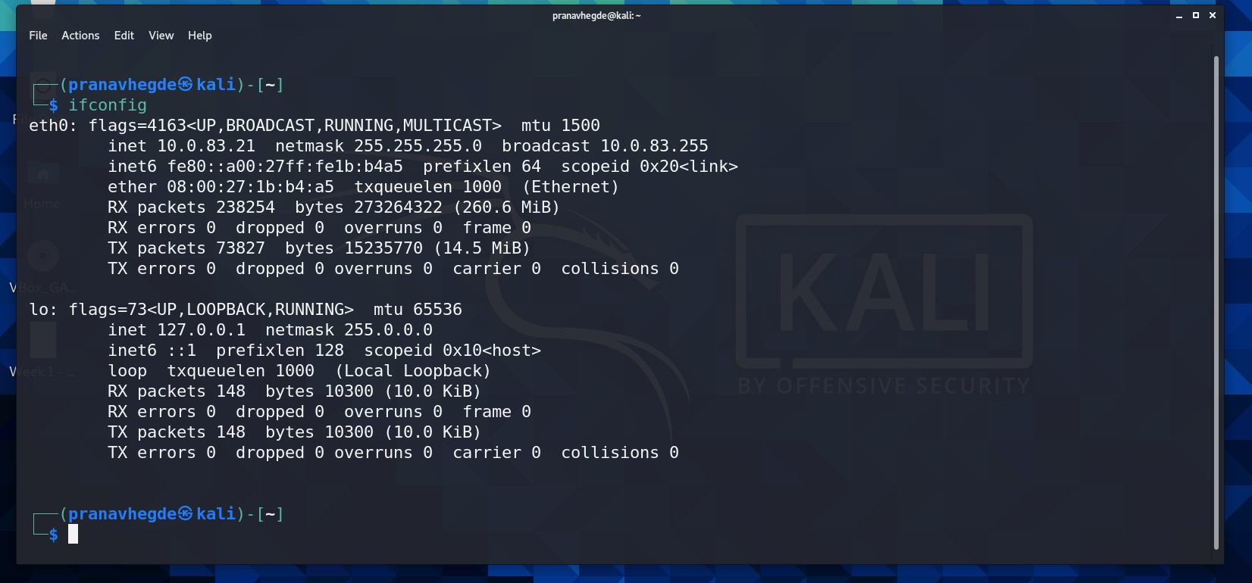

Step 2: assigning an IP address to an interface

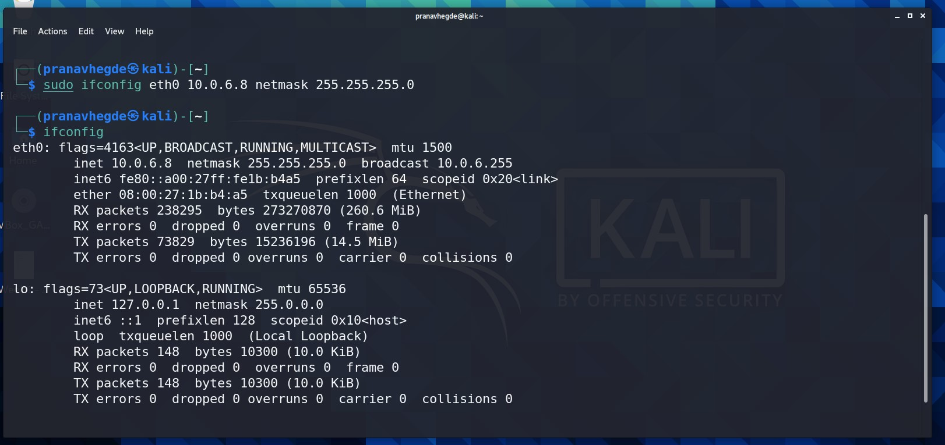

Section: F => (6)

Serial number in class: 8

So custom assigned IP address: 10.0.6.8

Step 3 and 4:

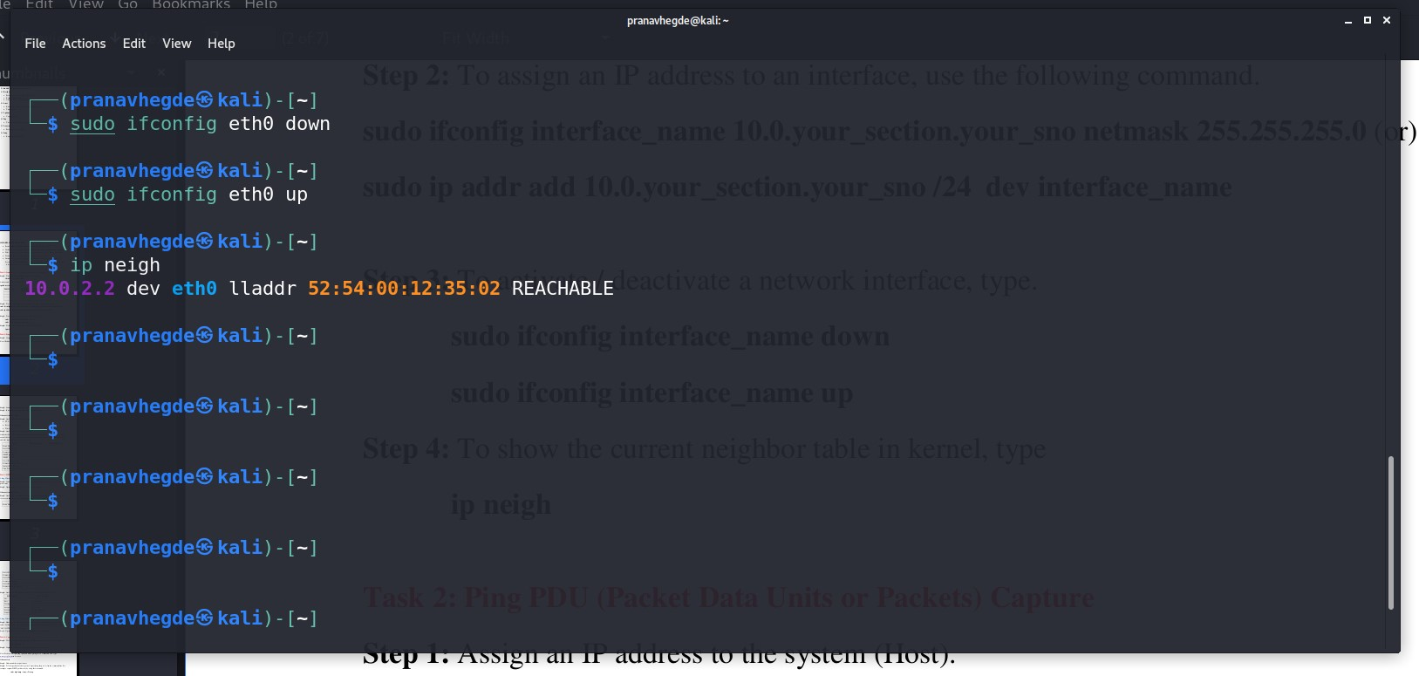

**TASK 2** (Ping PDU capture)

Step: Ping your IP and analyse the packet data in Wireshark

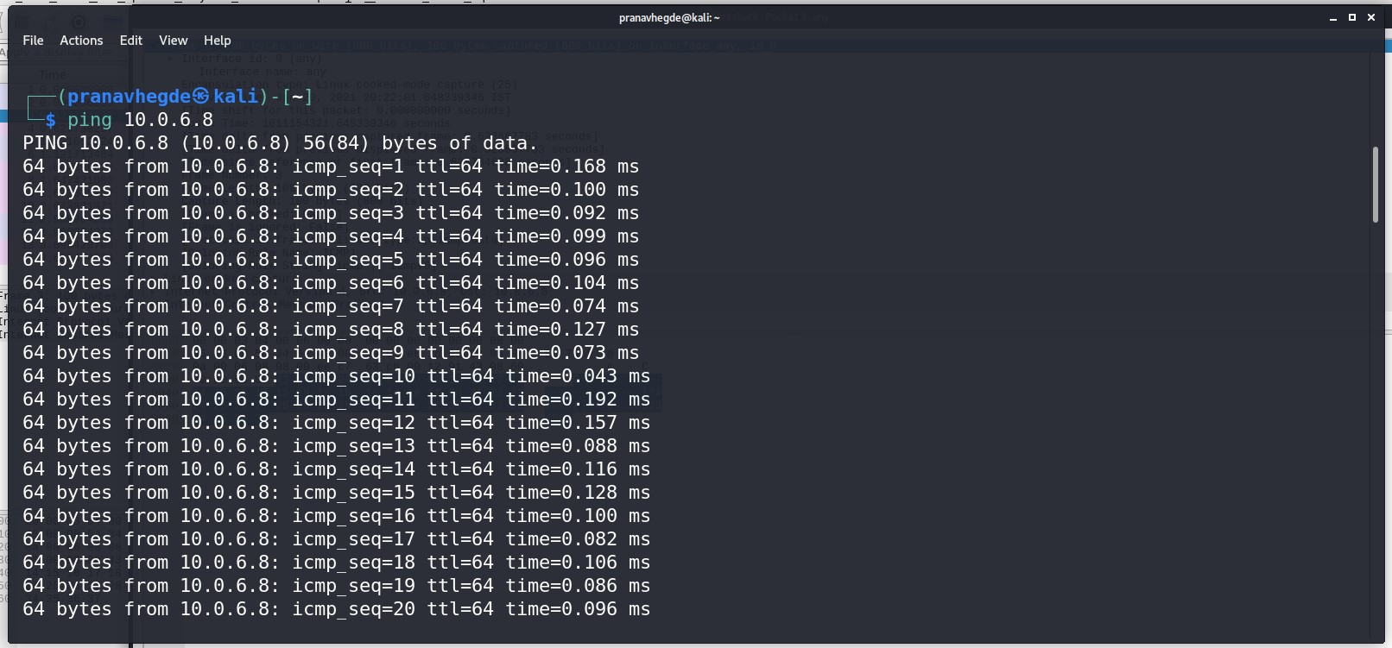

TTL: 64

Protocol used by ping: ICMP

Time: 0.168ms

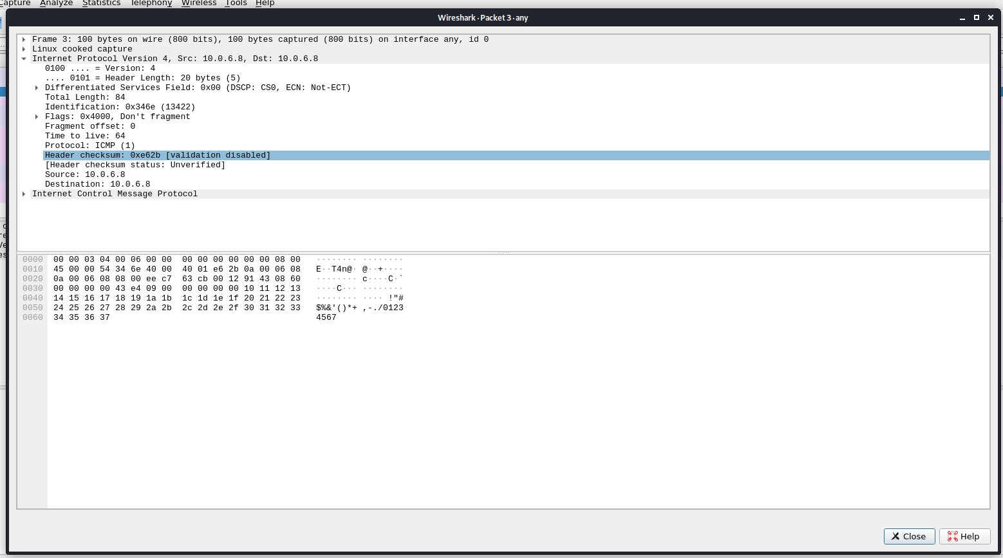

Wireshark data analysis:

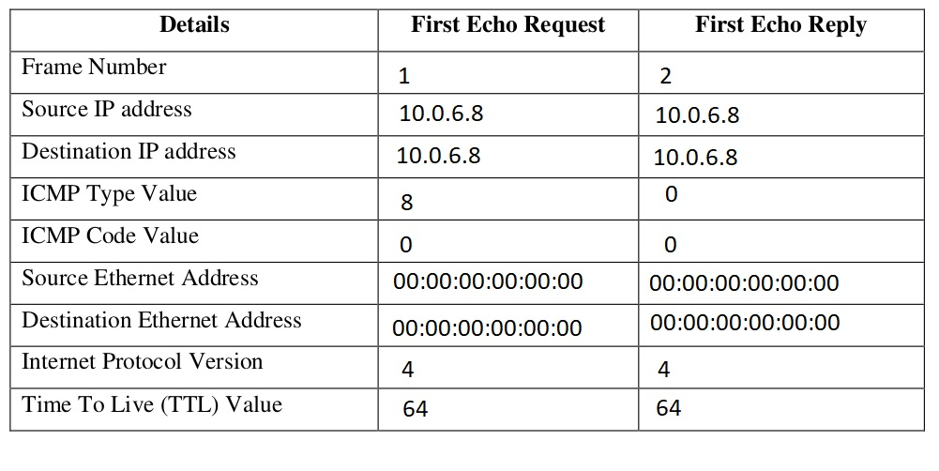

**TASK 3** (HTTP PDU capture)

Step: Visit amazon.com and analyse the packet data in Wireshark

My IP address: 10.0.2.15

Amazon.com IP address: 54.239.28.85

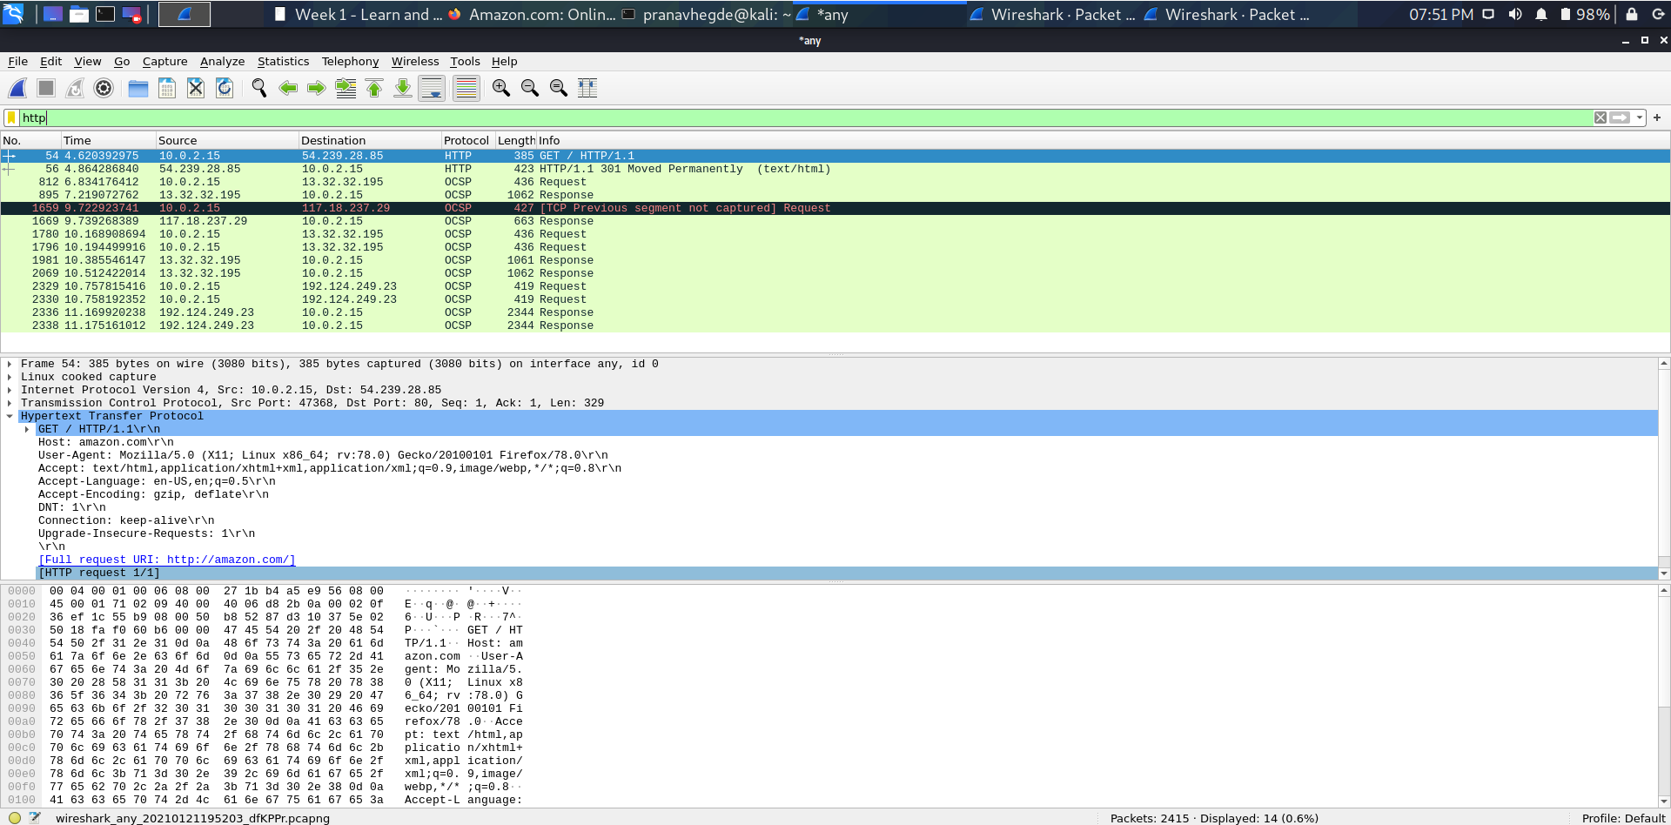

Wireshark first echo request / reply analysis:

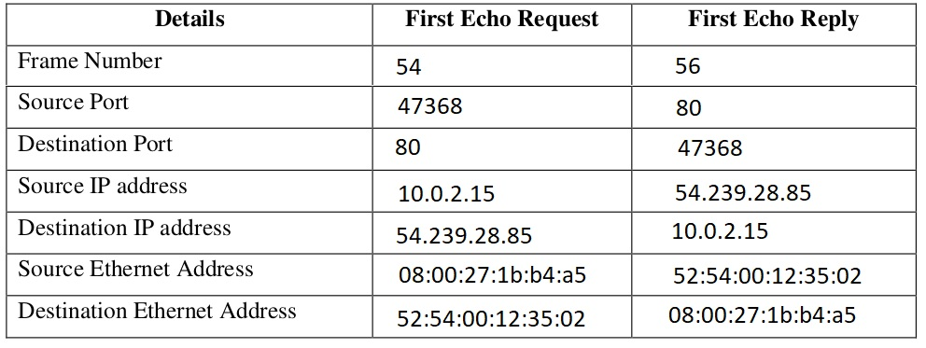

Wireshark HTTP request and response analysis:

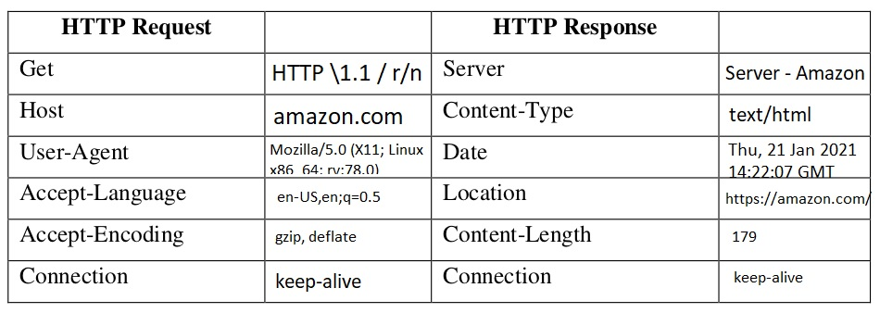

Follow TCP stream screenshot of a data packet

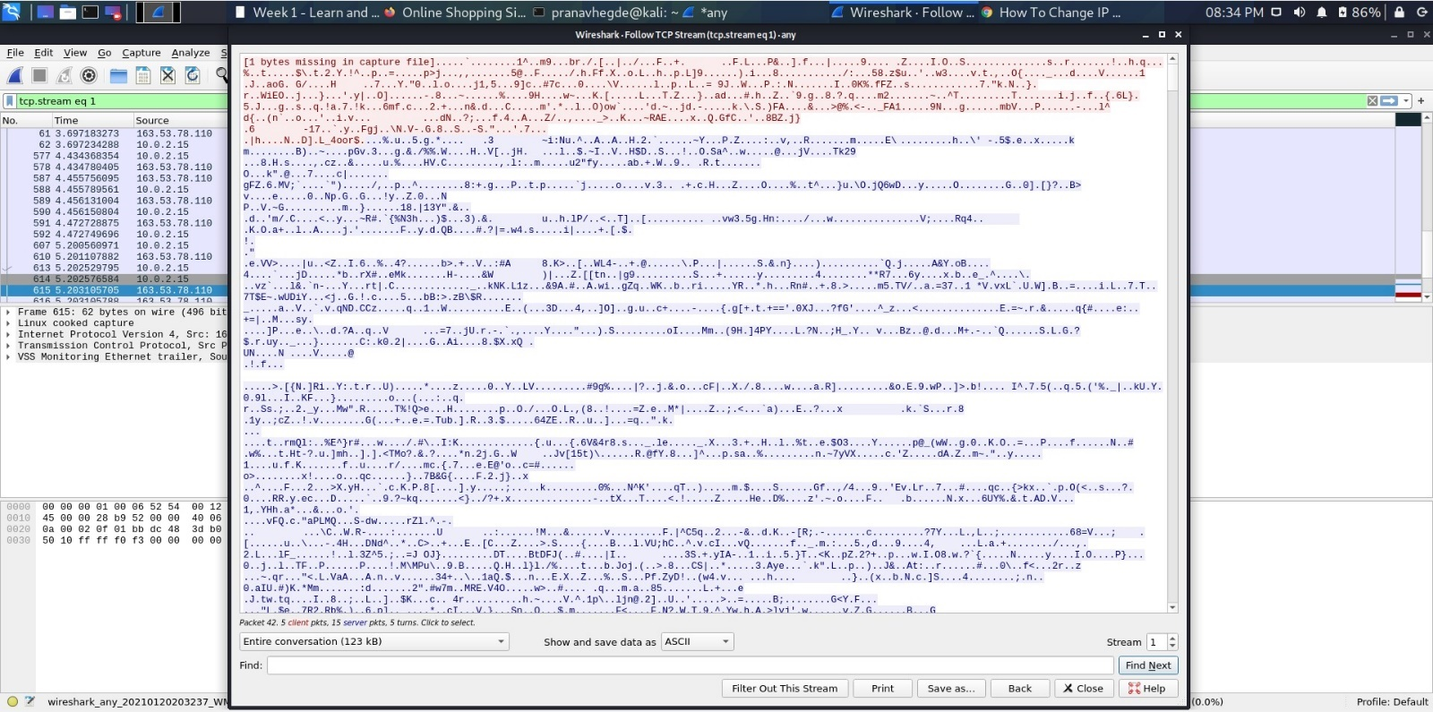

**TASK 4** (Capturing packets with TCP dump)

Step 1: sudo tcpdump -D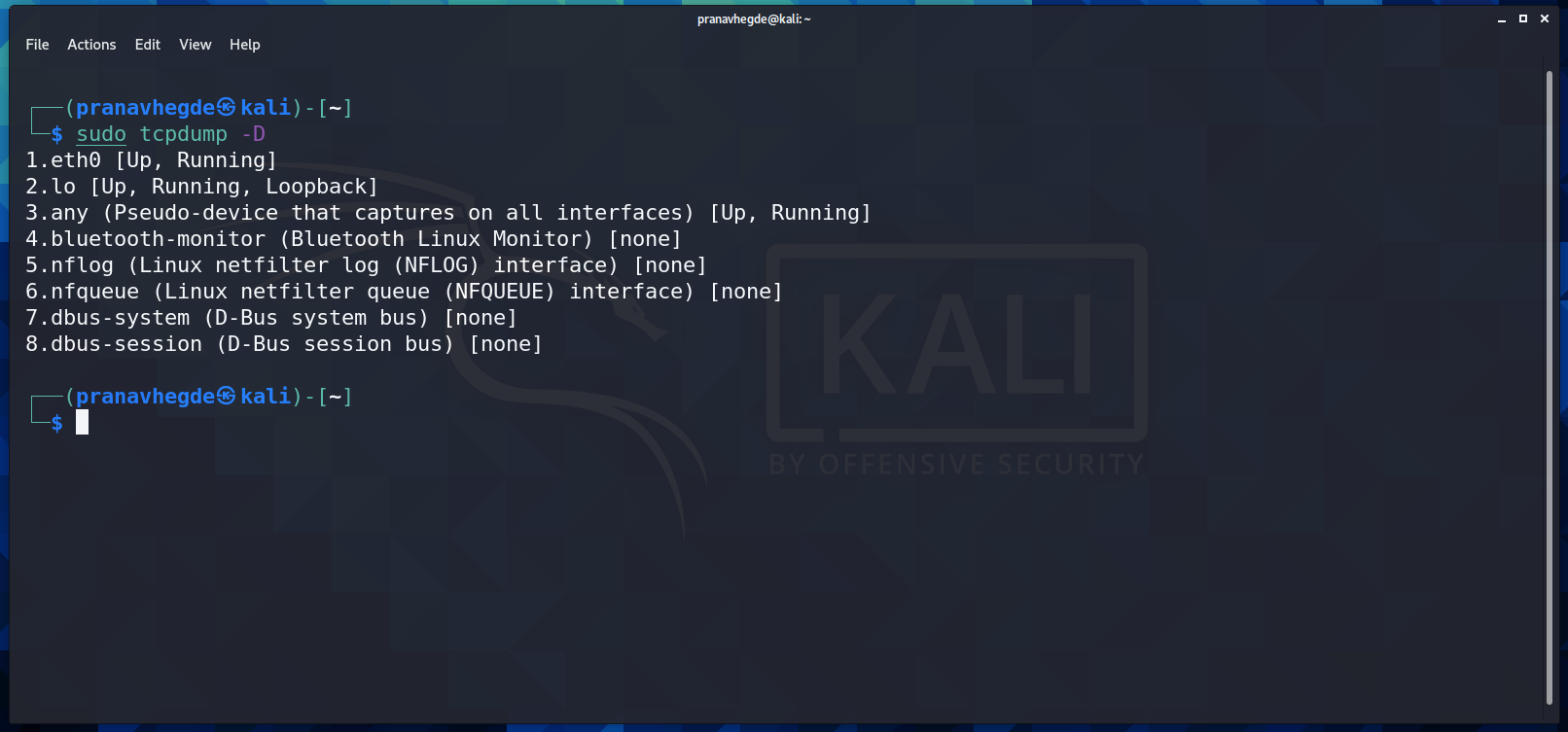

Step 2: sudo tcpdump -i any

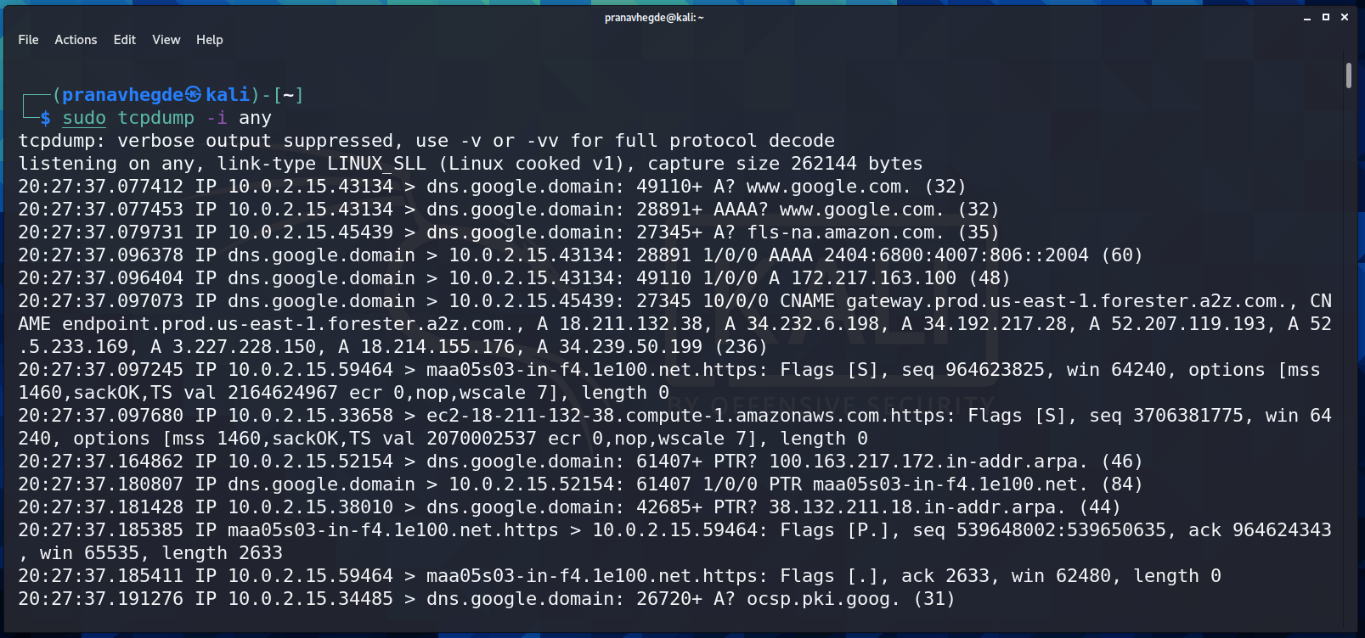

Step 3: sudo tcpdump -i any -c5 icmp 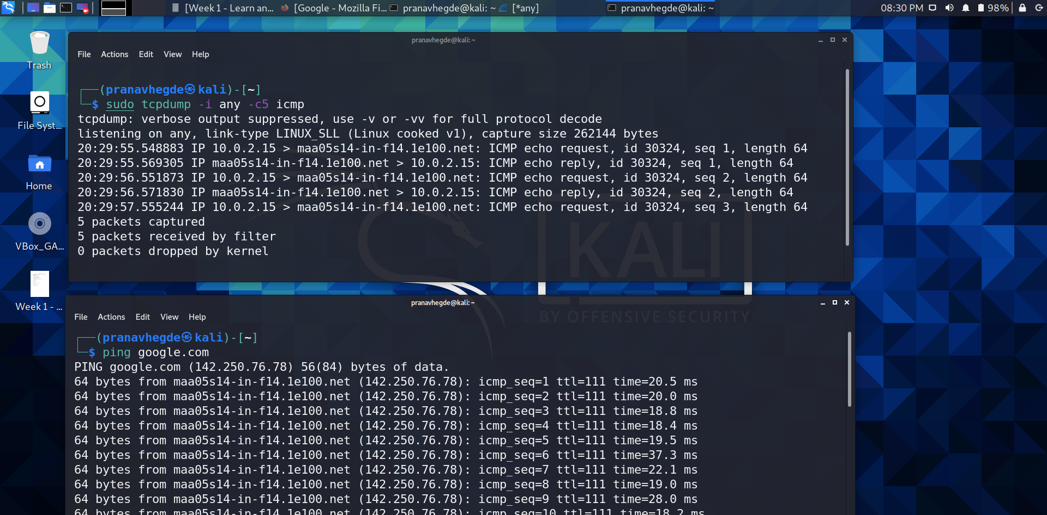

Step 4: sudo tcpdump -i any -c10 -nn -A port 80

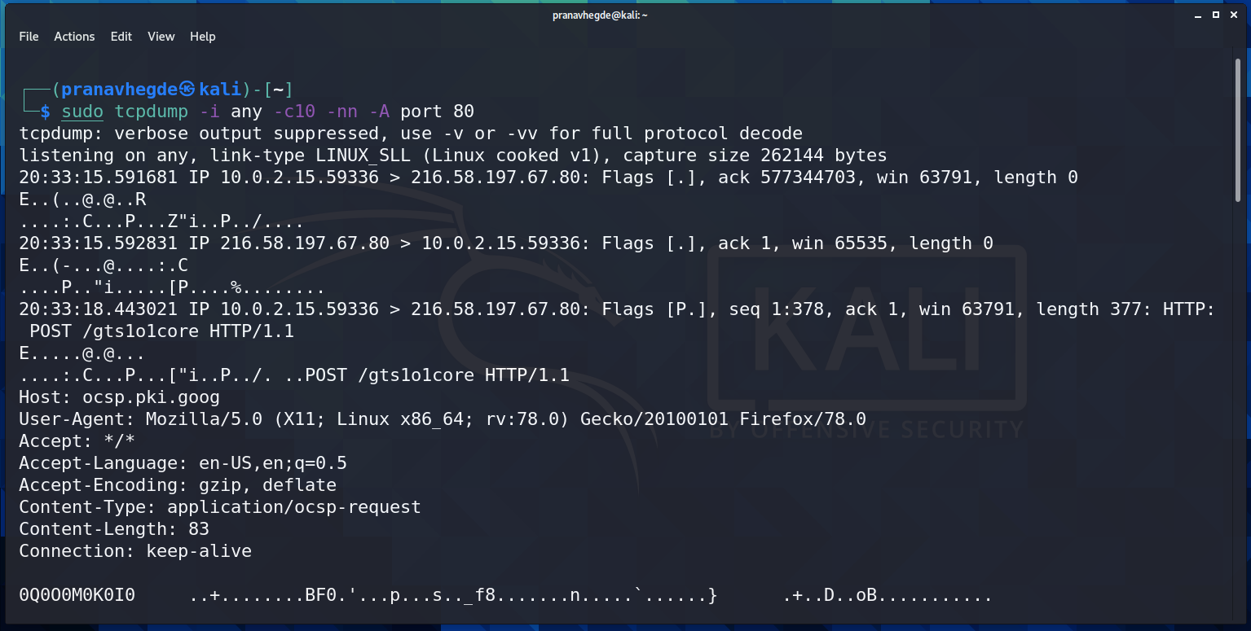

Step 5: sudo tcpdump -i any -c10 -nn -A port 80

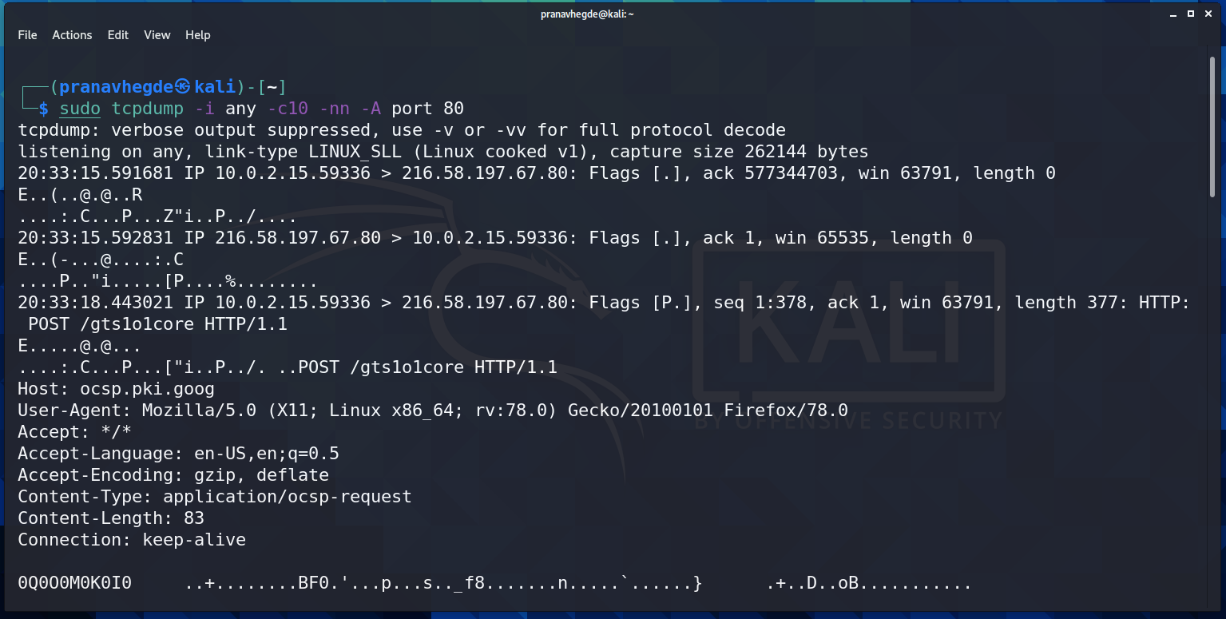

**TASK 5** (Perform traceroute checks)

Step 1: sudo traceroute google.com

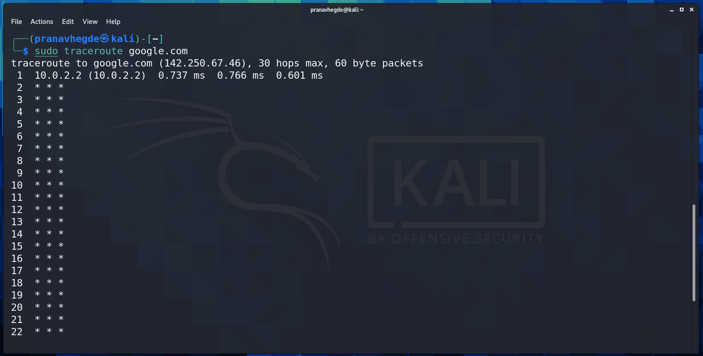

Address of google.com: 142.250.67.46

Number of max hops taken: 30

**TASK 6** (explore a network for info(nmap))

Step 1: nmap pes.edu

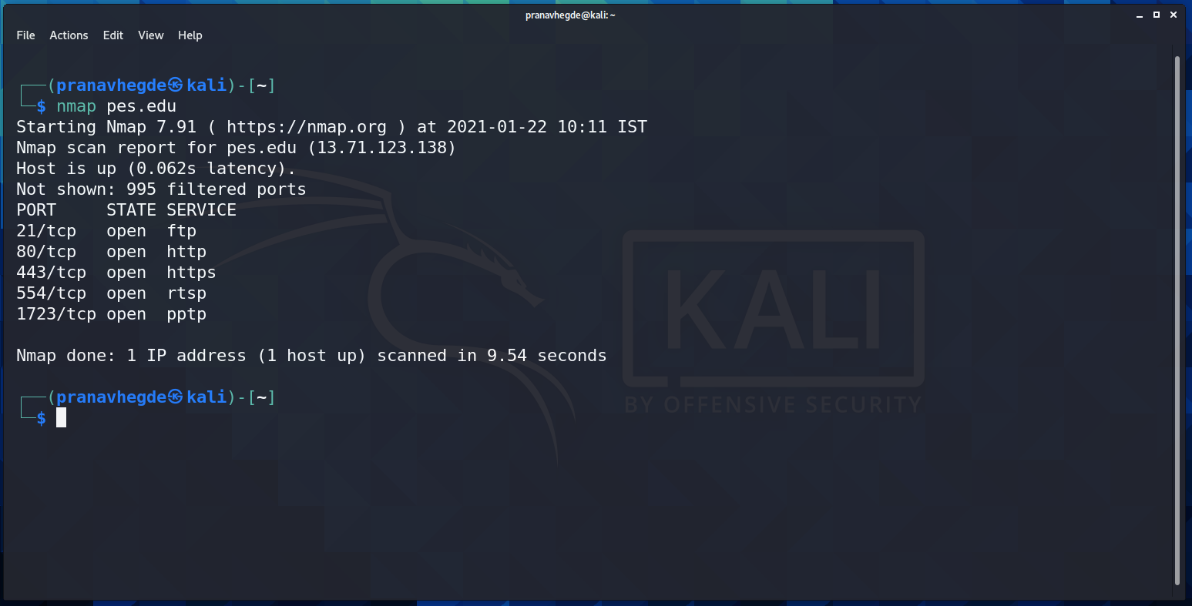

Step 2: nmap 163.53.78.128 and nmap 192.168.1.1 192.168.1.2 192.168.1.3

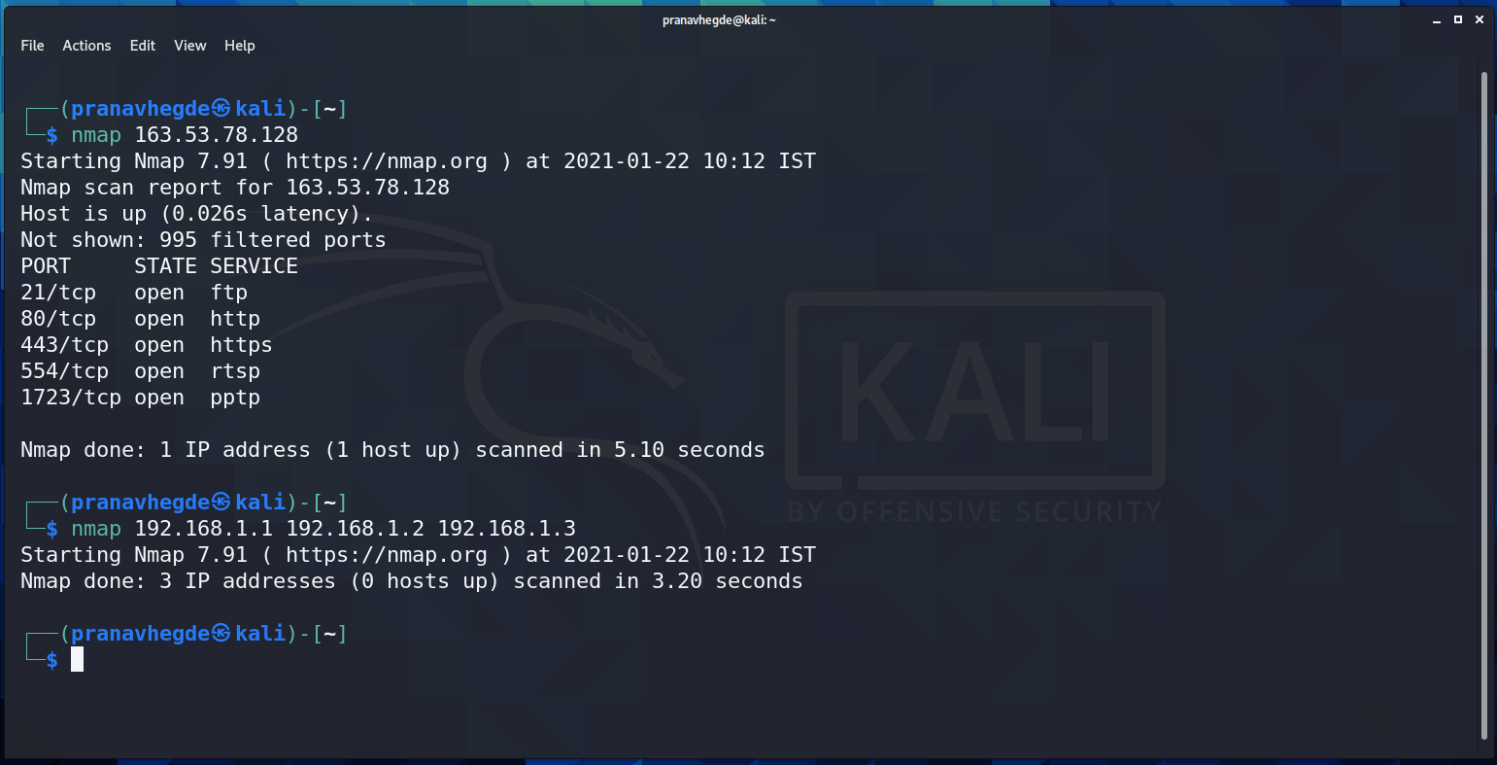

**TASK 7a** (Use netcat as a chat tool)

1. Intra system communication

Step 1: netcat command to perform intra system communication

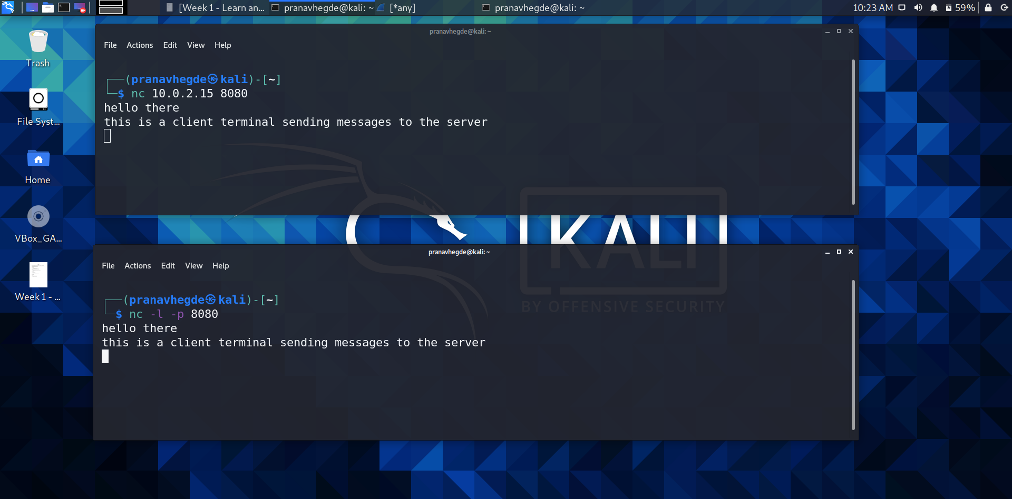

1. Inter system communication

Communication between a Windows 10 machine and Kali Linux Virtual machine (VirtualBox)

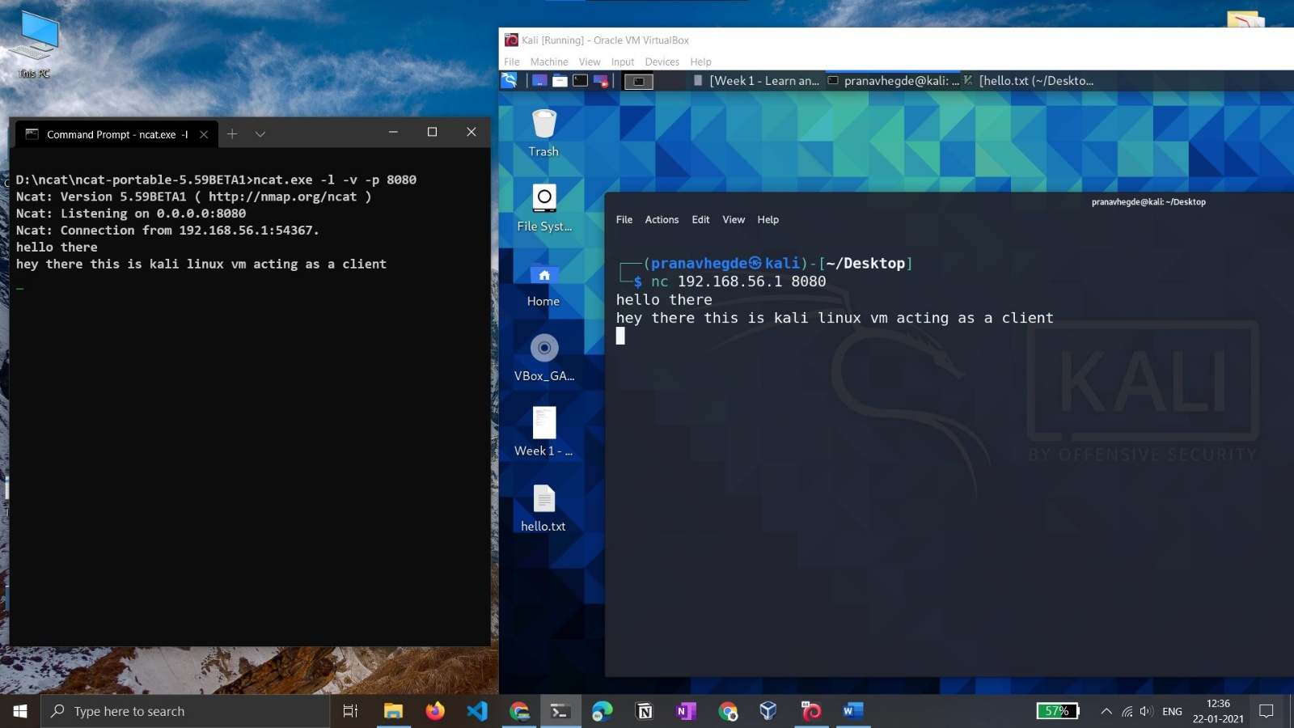

**TASK 7b** (Using netcat to transfer files)

Step: using netcat tool to transfer file from windows 10 CMD to kali Linux

